What is hot reload?

When we press the  button it does not make any changings. So, in order fix this we start our app in state less widget.

Step 1: write st and select stateless widget.

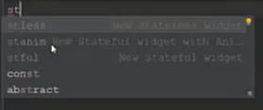

Step 2: full code here.

import 'package:flutter/material.dart';  
  
void main() => runApp(MyApp());  
  
class MyApp extends StatelessWidget {  
 @override  
 Widget build(BuildContext context) {  
 return MaterialApp(  
 home: Scaffold(  
 backgroundColor: Colors.*teal*,  
 body: Container(),  
 ),  
 );  
 }  
}

If we are going to press ctrl + s it will also hot reload the program.